**Retails Analytics Business Case Study**

**Contents**

**Datasets Intro 2**

**Approach for reading dataset: 3**

**Business Problem: 3**

**Approach to solve problem 4**

**Exploratory Data Analysis (EDA): 13**

**Recommandation to the problem: 45**

**Datasets Intro:**

* **Sales Transactions Dataset**: Records of sales transactions, including transaction ID, customer ID, product ID, quantity purchased, transaction date, and price.

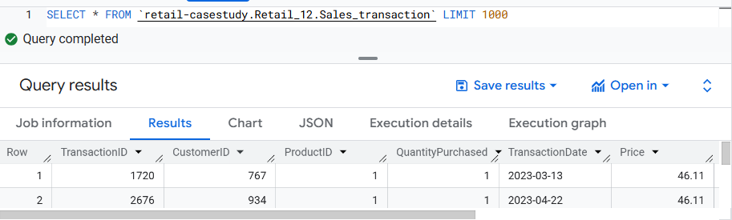

* **Customer Profiles Dataset**: Information on customers, including customer ID, age, gender, location, and join date.

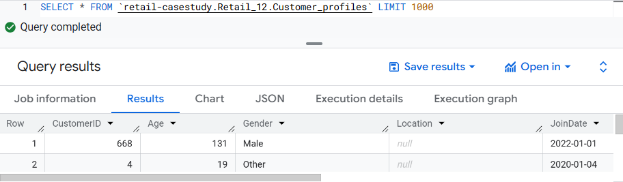

* **Product Inventory Dataset**: Data on product inventory, including product ID, product name, category, stock level, and price.

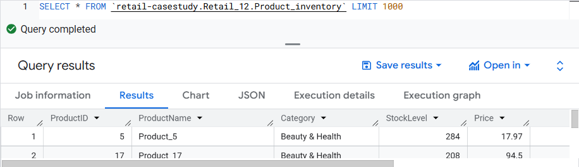

# **Approach for reading dataset:**

1. Login to Bigquery sanbox application of free account (To complete this case study using bigquery platform)
2. Created Project pickers or project folder on bigquery sanbox ( retail-casestudy)
3. Created the database name : Retail_12
4. Loaded all three files by creating tables with default schema check option (It automatically select datatype according to the dataset)

# **Business Problem:**

The retail company has observed stagnant growth and declining customer engagement metrics over the past quarters. Initial assessments indicate potential issues in product performance variability, ineffective customer segmentation, and a lack of insights into customer purchasing behavior.

The company seeks to leverage its sales transaction data, customer profiles, and product inventory information to address the following key business problems:

* **Product Performance Variability**: Identifying which products are performing well in terms of sales and which are not. This insight is crucial for inventory management and marketing focus.
* **Customer Segmentation**: The company lacks a clear understanding of its customer base segmentation. Effective segmentation is essential for targeted marketing and enhancing customer satisfaction.
* **Customer Behavior Analysis**: Understanding patterns in customer behavior, including repeat purchases and loyalty indicators, is critical for tailoring customer engagement strategies and improving retention rates.

# **Approach to solve problem**

Data Cleaning:

Sales_transaction table have 5002 total number of rows

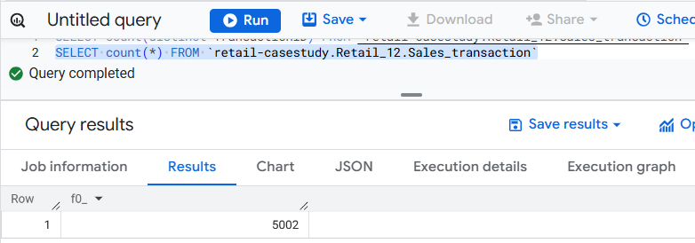

This query represent the duplicate number of transaction with number of count in sales_transaction table… It’s represent that table have two duplicate entry.

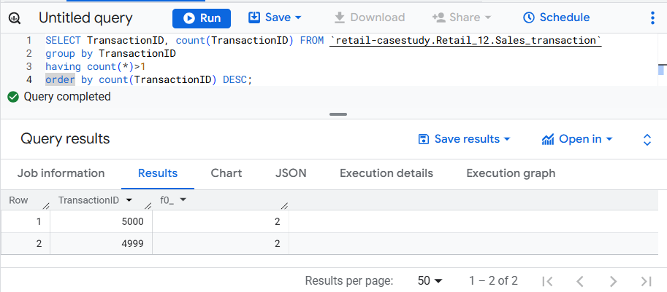

Query represent the unique records in sales_transaction table

SELECT * FROM `retail-casestudy.Retail_12.Sales_transaction` where TransactionID not in

(SELECT TransactionID FROM `retail-casestudy.Retail_12.Sales_transaction`

group by TransactionID

having count(*)>1

order by count(TransactionID) DESC)

order by TransactionID ASC, QuantityPurchased DESC;

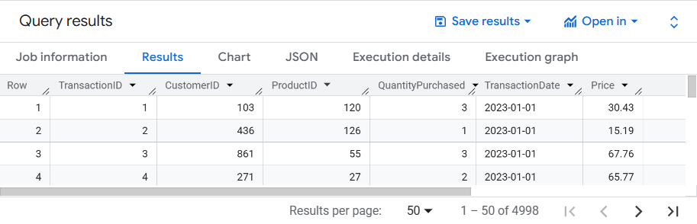

This represent how many the duplicate number of records present in sales_transaction

SELECT * FROM `retail-casestudy.Retail_12.Sales_transaction` where TransactionID in

(SELECT TransactionID FROM `retail-casestudy.Retail_12.Sales_transaction`

group by TransactionID

having count(*)>1

order by count(TransactionID) DESC);

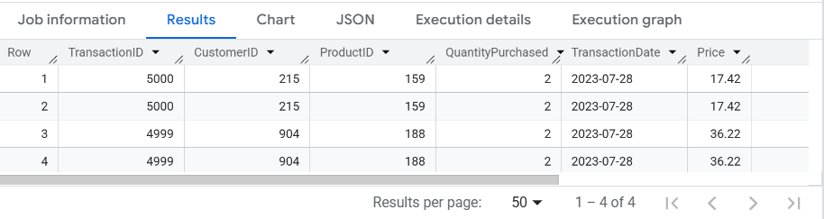

Checking any customerid column have null values.

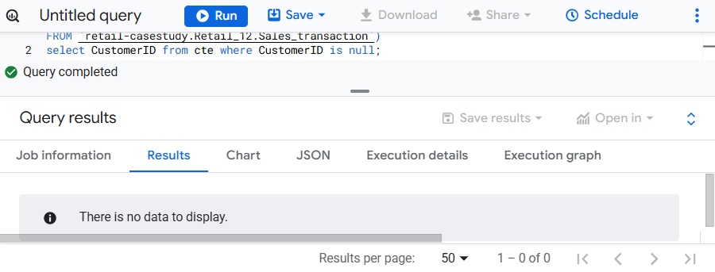

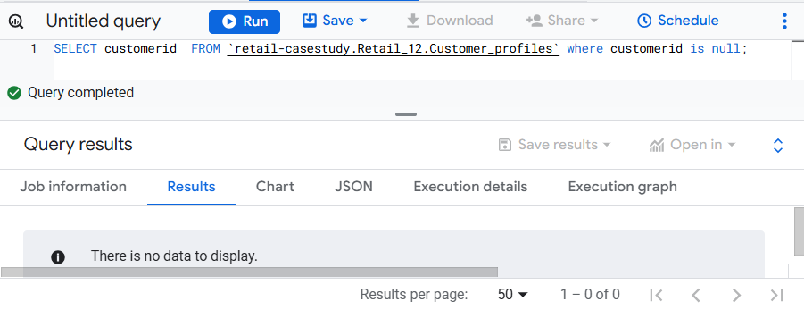

Checking any duplicate customerid are present in customer_profiles table or not

SELECT customerid, count(*)  FROM `retail-casestudy.Retail_12.Customer_profiles`

group by customerid

having count(*)>1;

Checking any age column value are null

SELECT Age  FROM `retail-casestudy.Retail_12.Customer_profiles` where Age is null;

Number of distinct gender present in customer profiles table

SELECT distinct Gender FROM `retail-casestudy.Retail_12.Customer_profiles`;

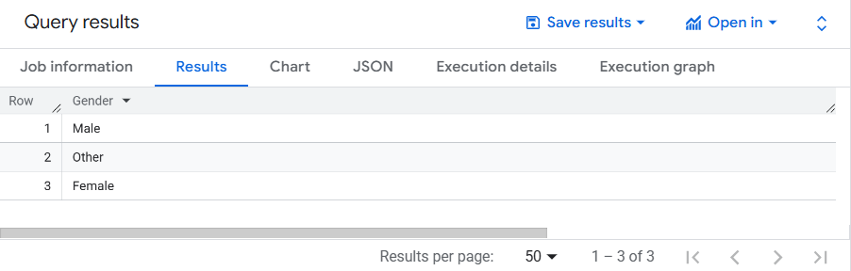

JoinDate column having any null entry or values

SELECT JoinDate FROM `retail-casestudy.Retail_12.Customer_profiles` where JoinDate is null;

Calculating the total number of customer present in particular or each location

SELECT Location, count(*) FROM `retail-casestudy.Retail_12.Customer_profiles`

group by Location;

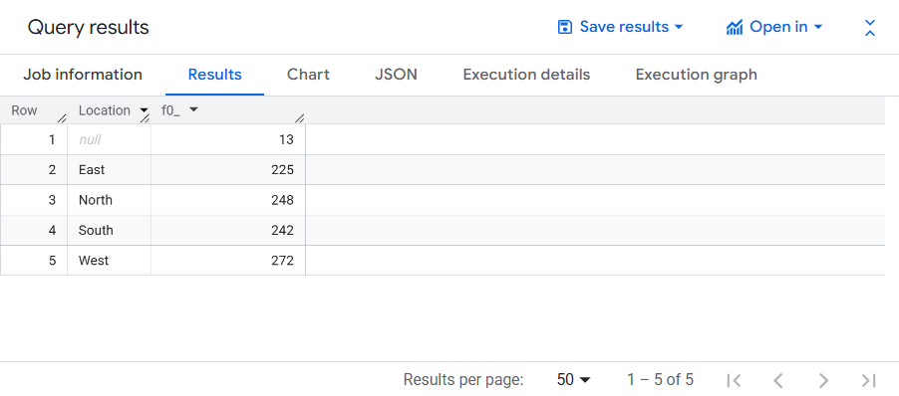

Just doing the sanity checks like all columns having proper values or null

SELECT productid FROM `retail-casestudy.Retail_12.Product_inventory` where productid is null;

Finding distinct number of produtname from profuct inventory table

SELECT distinct ProductName FROM `retail-casestudy.Retail_12.Product_inventory`;

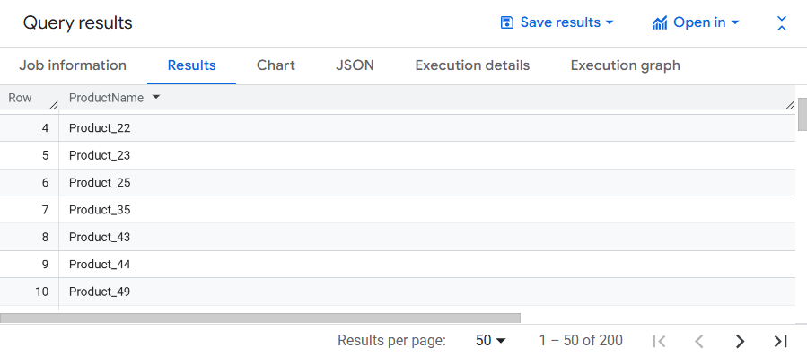

Total number of category with how many number of count’s are present in product inventory table

SELECT Category, count(*) FROM `retail-casestudy.Retail_12.Product_inventory` group by Category;

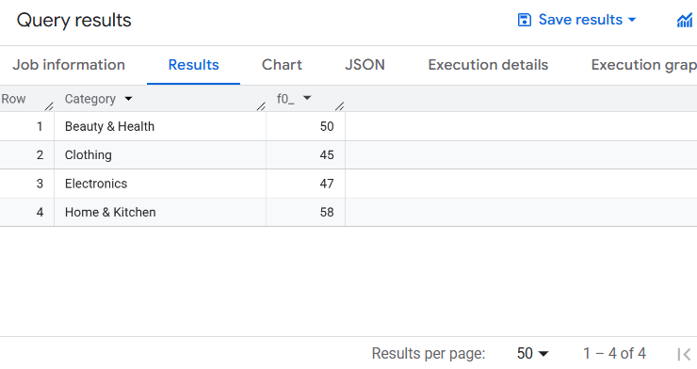

Calculating the number of stocklevel with total number of records for each stocklevel

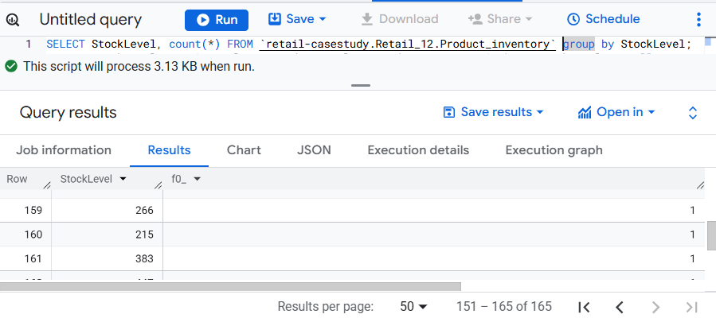

Calculating the number of price with total number of records for each price

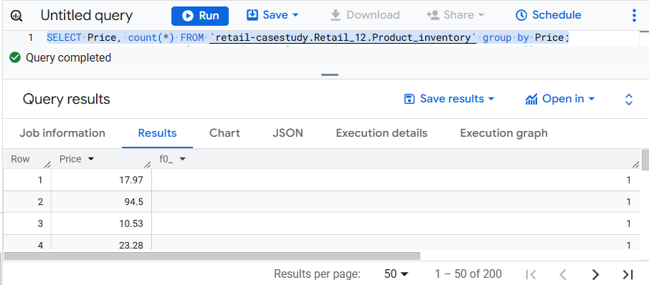

Creating the new table as **sales_transaction_new** for removal of duplicate records

CREATE TABLE `Retail_12.Sales_transaction_New` AS select * from (SELECT *, row_number() over(partition by TransactionID order by TransactionID) as cnt FROM `retail-casestudy.Retail_12.Sales_transaction`) as temp where cnt=1;

OR

CREATE TABLE `Retail_12.Sales_transaction_New` AS

SELECT distinct * FROM `retail-casestudy.Retail_12.Sales_transaction`;

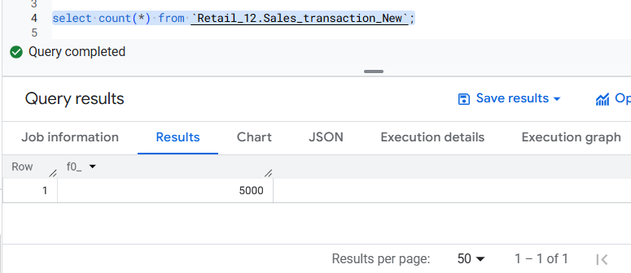

Note: Using Bigquery of free account only permits the DDL and DQL statement. No update operation are allowed in free account. To use update operation or command you have to pay the money.

After this all the query are preformed on MySQL workbench :

Create database retail_analysis_case_study if does not exists:

CREATE DATABASE if NOT EXISTS retail_analysis_case_study;

To check the all present databases in you mysql workbench:

SHOW DATABASES;

To use the particular database:

USE retail_analysis_case_study;

Table creation script for all three tables:

CREATE TABLE CUSTOMER_PROFILES (

CustomerID INT NOT NULL,

Age INT NOT NULL,

Gender VARCHAR(10),

Location VARCHAR(255),

JoinDate DATE NOT NULL

);

CREATE TABLE Sales_transaction (

TransactionID INT NOT NULL,

CustomerID INT NOT NULL,

ProductID INT NOT NULL,

QuantityPurchased INT NOT NULL,

TransactionDate DATE NOT NULL,

Price Decimal(38,5)

);

CREATE TABLE Product_inventory (

ProductID INT NOT NULL,

ProductName VARCHAR(100) NOT NULL,

Category VARCHAR(50) NOT NULL,

StockLevel INT NOT NULL,

Price Decimal(38,5)

);

Finding the transaction or productid of price which does not match with the product_inventory table price because the product_inventory table is represent the details about the product

select * from sales_transaction_new

where productid in (select productid from product_inventory)

and price not in (select price from product_inventory);

With out enabling the SAFE mode we can’t perform the update operation in mysql

SET SQL_SAFE_UPDATES = 0;

Updating the incorrect price of product in sales_transaction table from product_inventory table

update sales_transaction_new st

JOIN product_inventory as pi

ON st.productid = pi.productid

SET st.price = pi.price

where st.price <> pi.price;

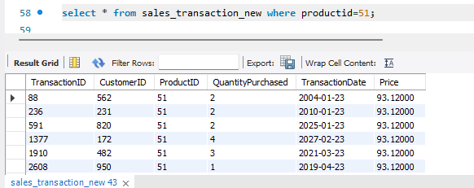

Product_inventory table of productid=51 having the correct value and this value are update to sales_transaction table of price

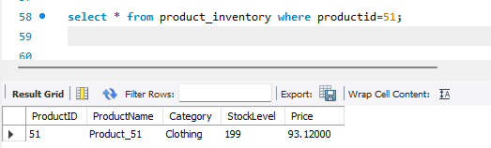

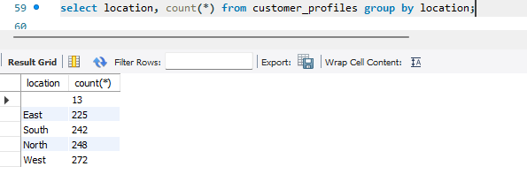

69 rows are found in output of join query. It’s present that 69 records having blank location.

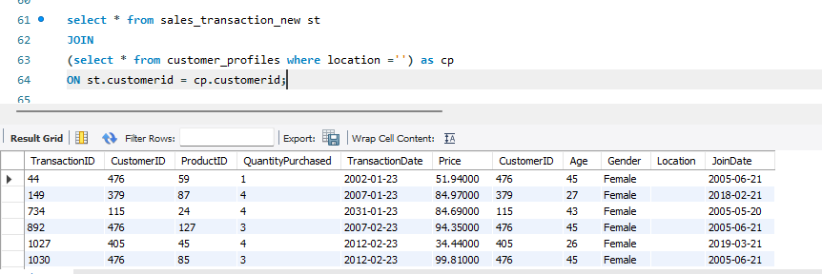

Using the update query location blank update to Unkow .

Reson for updating ‘Uknow’ value :

1. Because total number of blank location in customer profiles table having 13 records if I remove this record then it’s entry present to sales transaction table will be automatically went out.
2. Imputing with mode is also the option but I refer to the know the how many records are unknow.

This is update query to update the blank location to ‘Unknow’ value

update customer_profiles set location='Unknow' where location='';

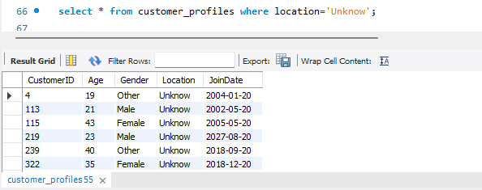

# **Exploratory Data Analysis (EDA):**

Perform basic product performance overview, customer purchase frequency analysis, and product categories performance evaluation.

**Product performance overview:**

Mostly the customer joined or login the application to purchase the product from 2001 till 2031. Customer profile table contains data from 2001 till 2031

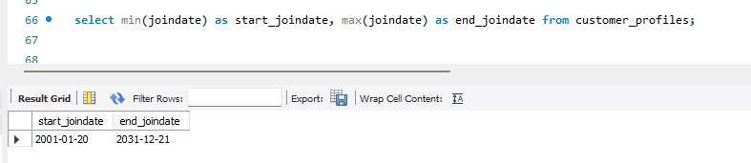

Transaction started from 2001 and last or till date transaction occurred 2031 year

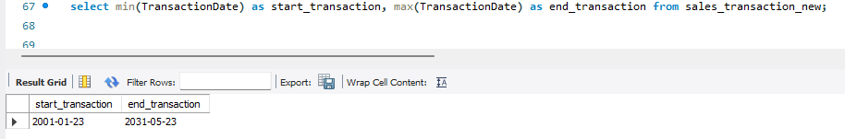

Product 17 are brought more and this product have the highest sales_revenue

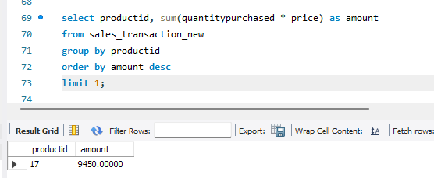

Productid – 139 having the lowest revenue or amount from all the product

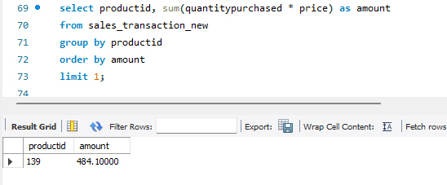

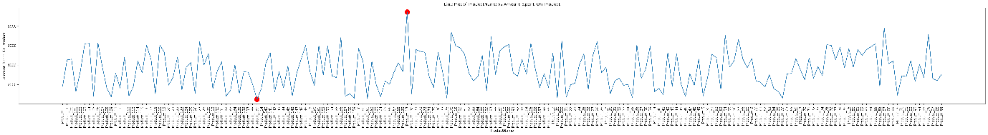

Product -17 was purchase by 39 customer

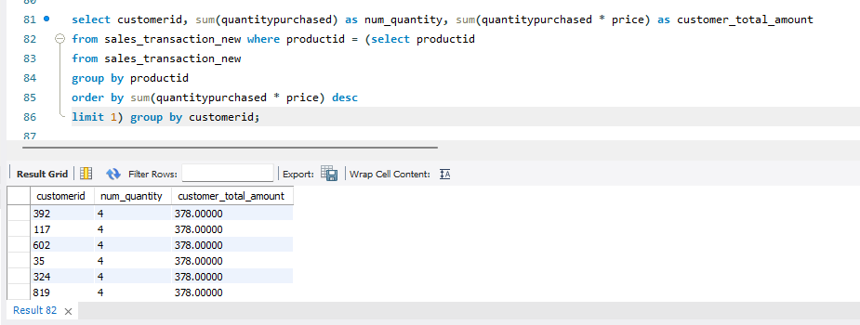

Product – 139 was purchase by 18 customer and cost of the product is 10.30

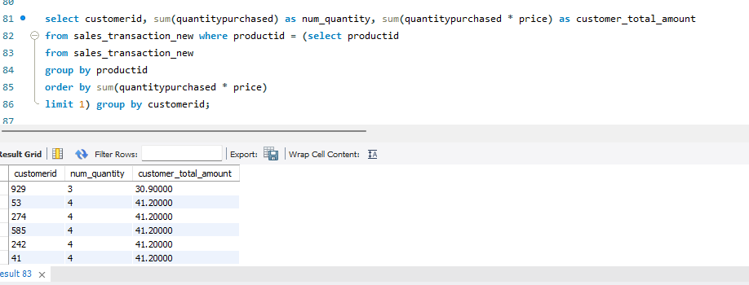

From the product inventory table finding the lowest and highest price of product with displaying the all details of product

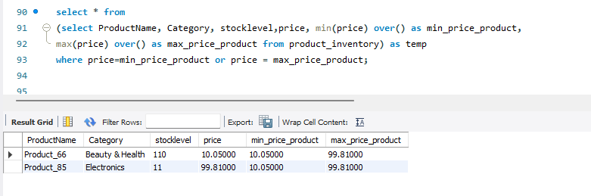

Total revenue generated through the lowest or highest price product from sales_transaction table and found that the product price which are highest or lowest in product table they are not highest or lowest in sales transaction table

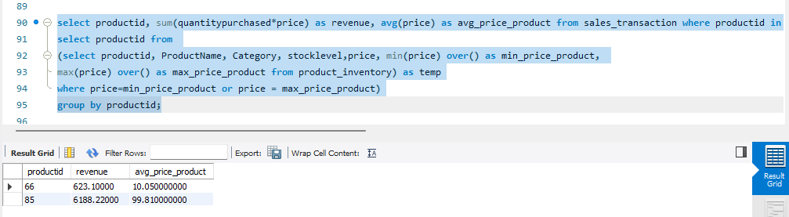

WITH CTE AS

(select productid as max_product_sale_id, round(sum(quantitypurchased * price)) as max_prod_total_revenue

from sales_transaction_new

group by productid

order by max_prod_total_revenue desc

limit 1),

min_prod_price as

(select productid as min_product_sale_id, round(sum(quantitypurchased * price)) as min_prod_total_revenue

from sales_transaction_new

group by productid

order by min_prod_total_revenue

limit 1)

select max_product_sale_id, max_prod_total_revenue, min_product_sale_id, min_prod_total_revenue from CTE, min_prod_price;

This query represent the highest and lowest revenue generated by product from sale transaction new table

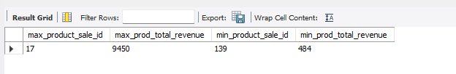

Total number of product or records present in product inventory table

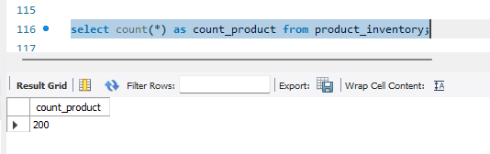

WITH CTE AS

(select productid, concat(Year(TransactionDate),'-', Month(TransactionDate)) as Month_Year_Transaction,

SUM(QuantityPurchased * Price) as total_revenue, avg(price) as avg_price

from sales_transaction_new

group by productid, Month_Year_Transaction),

product_in as

(select productid, concat(productName,'_',category) as productnamecategory from product_inventory),

product_summary as

(select pi.productnamecategory, cte.Month_Year_Transaction, cte.total_revenue, cte.avg_price from cte

JOIN product_in as pi

ON cte.productid = pi.productid

order by pi.productnamecategory asc, cte.Month_Year_Transaction desc)

select * from product_summary;

Calculating the category wise product item with there month and year wise total revenue as well as average price of product.

This represent the each product in each month of year generating how many revenue for retail company.

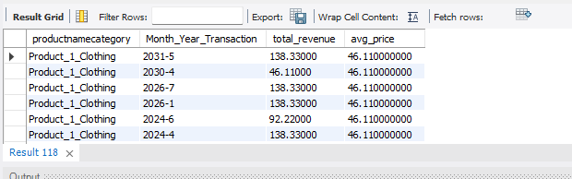

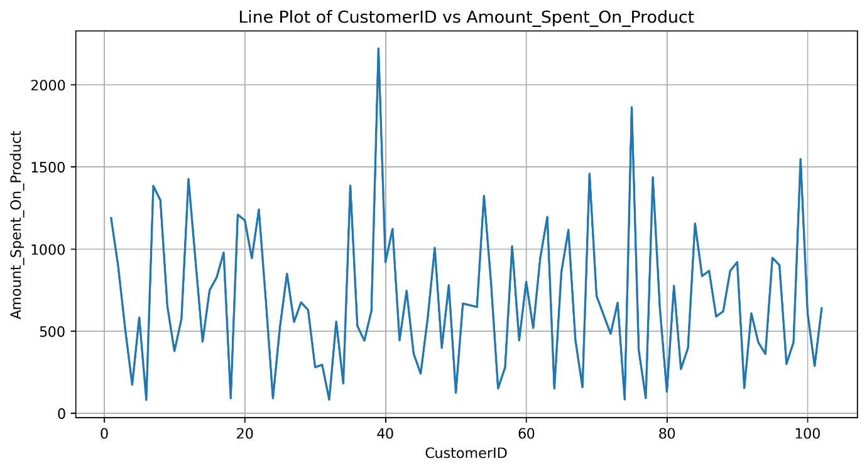

WITH CTE AS

(select productid, concat(Year(TransactionDate),'-', Month(TransactionDate)) as Month_Year_Transaction,

SUM(QuantityPurchased * Price) as total_revenue, avg(price) as avg_price

from sales_transaction_new

group by productid, Month_Year_Transaction),

product_in as

(select productid, concat(productName,'_',category) as productnamecategory from product_inventory),

product_summary as

(select pi.productnamecategory, cte.Month_Year_Transaction, cte.total_revenue, cte.avg_price from cte

JOIN product_in as pi

ON cte.productid = pi.productid

order by pi.productnamecategory asc, cte.Month_Year_Transaction desc)

select Month_Year_Transaction,

sum(CASE WHEN productnamecategory like '%1%' THEN total_revenue END) AS product_1,

sum(CASE WHEN productnamecategory like '%2%' THEN total_revenue END) AS product_2,

sum(CASE WHEN productnamecategory like '%3%' THEN total_revenue END) AS product_3,

sum(CASE WHEN productnamecategory like '%4%' THEN total_revenue END) AS product_4,

sum(CASE WHEN productnamecategory like '%5%' THEN total_revenue END) AS product_5,

sum(CASE WHEN productnamecategory like '%6%' THEN total_revenue END) AS product_6,

sum(CASE WHEN productnamecategory like '%7%' THEN total_revenue END) AS product_7,

sum(CASE WHEN productnamecategory like '%8%' THEN total_revenue END) AS product_8,

sum(CASE WHEN productnamecategory like '%9%' THEN total_revenue END) AS product_9,

sum(CASE WHEN productnamecategory like '%10%' THEN total_revenue END) AS product_10,

sum(CASE WHEN productnamecategory like '%11%' THEN total_revenue END) AS product_11,

sum(CASE WHEN productnamecategory like '%12%' THEN total_revenue END) AS product_12,

sum(CASE WHEN productnamecategory like '%13%' THEN total_revenue END) AS product_13,

sum(CASE WHEN productnamecategory like '%14%' THEN total_revenue END) AS product_14,

sum(CASE WHEN productnamecategory like '%15%' THEN total_revenue END) AS product_15,

sum(CASE WHEN productnamecategory like '%16%' THEN total_revenue END) AS product_16,

sum(CASE WHEN productnamecategory like '%17%' THEN total_revenue END) AS product_17,

sum(CASE WHEN productnamecategory like '%18%' THEN total_revenue END) AS product_18,

sum(CASE WHEN productnamecategory like '%19%' THEN total_revenue END) AS product_19,

sum(CASE WHEN productnamecategory like '%20%' THEN total_revenue END) AS product_20

from product_summary

group by Month_Year_Transaction;

It’s just a tabular format of revenue generated by each product in each month of years.

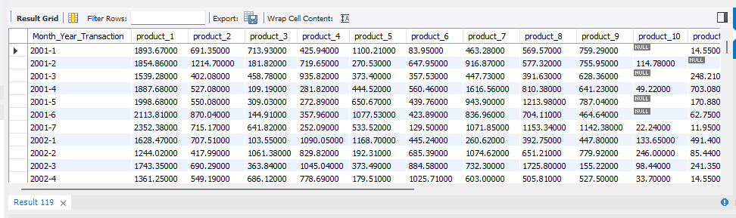

WITH CTE AS

(select productid, Month(TransactionDate) as Month_Transaction,

SUM(QuantityPurchased * Price) as total_revenue, avg(price) as avg_price

from sales_transaction_new

group by productid, Month_Transaction),

product_in as

(select productid, concat(productName,'_',category) as productnamecategory from product_inventory),

product_summary as

(select pi.productnamecategory, cte.Month_Transaction, cte.total_revenue, cte.avg_price from cte

JOIN product_in as pi

ON cte.productid = pi.productid

order by pi.productnamecategory asc, cte.Month_Transaction desc)

select productnamecategory,

SUM(CASE WHEN Month_Transaction=1 THEN total_revenue ELSE 0 END) AS 'JAN',

SUM(CASE WHEN Month_Transaction=2 THEN total_revenue ELSE 0 END) AS 'FEB',

SUM(CASE WHEN Month_Transaction=3 THEN total_revenue ELSE 0 END) AS 'MAR',

SUM(CASE WHEN Month_Transaction=4 THEN total_revenue ELSE 0 END) AS 'APR',

SUM(CASE WHEN Month_Transaction=5 THEN total_revenue ELSE 0 END) AS 'MAY',

SUM(CASE WHEN Month_Transaction=6 THEN total_revenue ELSE 0 END) AS 'JUN',

SUM(CASE WHEN Month_Transaction=7 THEN total_revenue ELSE 0 END) AS 'JUL',

SUM(CASE WHEN Month_Transaction=8 THEN total_revenue ELSE 0 END) AS 'AUG',

SUM(CASE WHEN Month_Transaction=9 THEN total_revenue ELSE 0 END) AS 'SEP',

SUM(CASE WHEN Month_Transaction=10 THEN total_revenue ELSE 0 END) AS 'OCT',

SUM(CASE WHEN Month_Transaction=11 THEN total_revenue ELSE 0 END) AS 'NOV',

SUM(CASE WHEN Month_Transaction=12 THEN total_revenue ELSE 0 END) AS 'DEC',

sum(total_revenue) as total_revenue_of_each_product

from product_summary

group by productnamecategory

order by productnamecategory;

Representing the month wise product purchase amount. It’s show that transaction occurred in between Jan till July but after this no sales for four months.

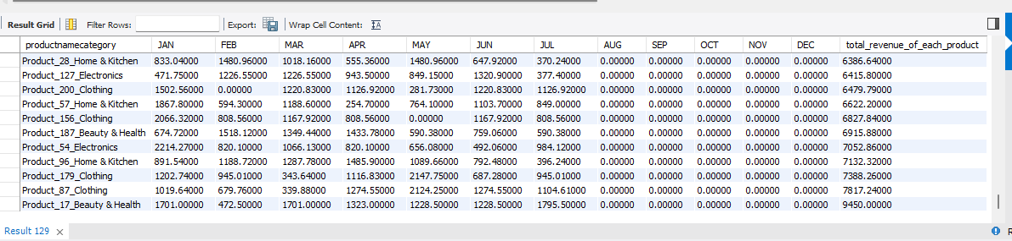

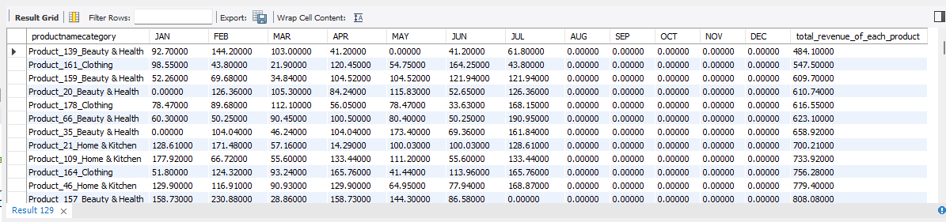

WITH CTE AS

(select productid, Month(TransactionDate) as Month_Transaction,

SUM(QuantityPurchased * Price) as total_revenue, avg(price) as avg_price

from sales_transaction_new

group by productid, Month_Transaction),

product_in as

(select productid, category as productcategory from product_inventory),

product_summary as

(select pi.productcategory, cte.Month_Transaction, cte.total_revenue, cte.avg_price from cte

JOIN product_in as pi

ON cte.productid = pi.productid

order by pi.productcategory asc, cte.Month_Transaction desc)

select productcategory,

SUM(CASE WHEN Month_Transaction=1 THEN total_revenue ELSE 0 END) AS 'JAN',

SUM(CASE WHEN Month_Transaction=2 THEN total_revenue ELSE 0 END) AS 'FEB',

SUM(CASE WHEN Month_Transaction=3 THEN total_revenue ELSE 0 END) AS 'MAR',

SUM(CASE WHEN Month_Transaction=4 THEN total_revenue ELSE 0 END) AS 'APR',

SUM(CASE WHEN Month_Transaction=5 THEN total_revenue ELSE 0 END) AS 'MAY',

SUM(CASE WHEN Month_Transaction=6 THEN total_revenue ELSE 0 END) AS 'JUN',

SUM(CASE WHEN Month_Transaction=7 THEN total_revenue ELSE 0 END) AS 'JUL',

SUM(CASE WHEN Month_Transaction=8 THEN total_revenue ELSE 0 END) AS 'AUG',

SUM(CASE WHEN Month_Transaction=9 THEN total_revenue ELSE 0 END) AS 'SEP',

SUM(CASE WHEN Month_Transaction=10 THEN total_revenue ELSE 0 END) AS 'OCT',

SUM(CASE WHEN Month_Transaction=11 THEN total_revenue ELSE 0 END) AS 'NOV',

SUM(CASE WHEN Month_Transaction=12 THEN total_revenue ELSE 0 END) AS 'DEC',

sum(total_revenue) as total_revenue_of_each_category

from product_summary

group by productcategory

order by productcategory;

Product category wise purchase pattern for each month.

It’s represent that Home & Kitchen have the highest revenue from all the category of product and lowest one is Beauty & Health category.

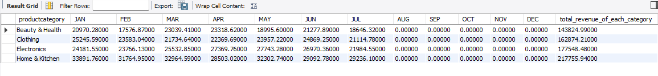

WITH CTE AS

(select productid, YEAR(TransactionDate) as year_Transaction,

SUM(QuantityPurchased * Price) as total_revenue, avg(price) as avg_price

from sales_transaction_new

group by productid, year_Transaction),

product_in as

(select productid, category as productcategory from product_inventory),

product_summary as

(select pi.productcategory, cte.year_Transaction, cte.total_revenue, cte.avg_price from cte

JOIN product_in as pi

ON cte.productid = pi.productid

order by pi.productcategory asc, cte.year_Transaction desc)

select year_Transaction,

SUM(CASE WHEN productcategory='Beauty & Health' THEN total_revenue ELSE 0 END) AS 'Beauty & Health',

SUM(CASE WHEN productcategory='Clothing' THEN total_revenue ELSE 0 END) AS 'Clothing',

SUM(CASE WHEN productcategory='Electronics' THEN total_revenue ELSE 0 END) AS 'Electronics',

SUM(CASE WHEN productcategory='Home & Kitchen' THEN total_revenue ELSE 0 END) AS 'Home & Kitchen',

GREATEST(

SUM(CASE WHEN productcategory='Beauty & Health' THEN total_revenue ELSE 0 END),

SUM(CASE WHEN productcategory='Clothing' THEN total_revenue ELSE 0 END),

SUM(CASE WHEN productcategory='Electronics' THEN total_revenue ELSE 0 END),

SUM(CASE WHEN productcategory='Home & Kitchen' THEN total_revenue ELSE 0 END)

) AS Max_Category_Revenue

from product_summary

group by year_Transaction

order by year_Transaction;

Category wise per year revenue generated

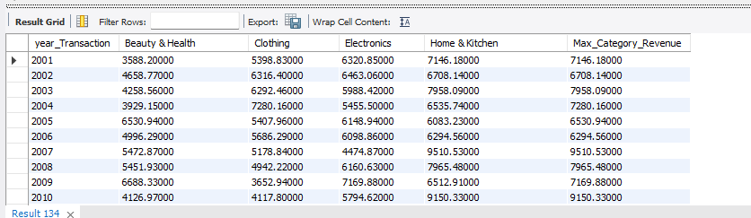

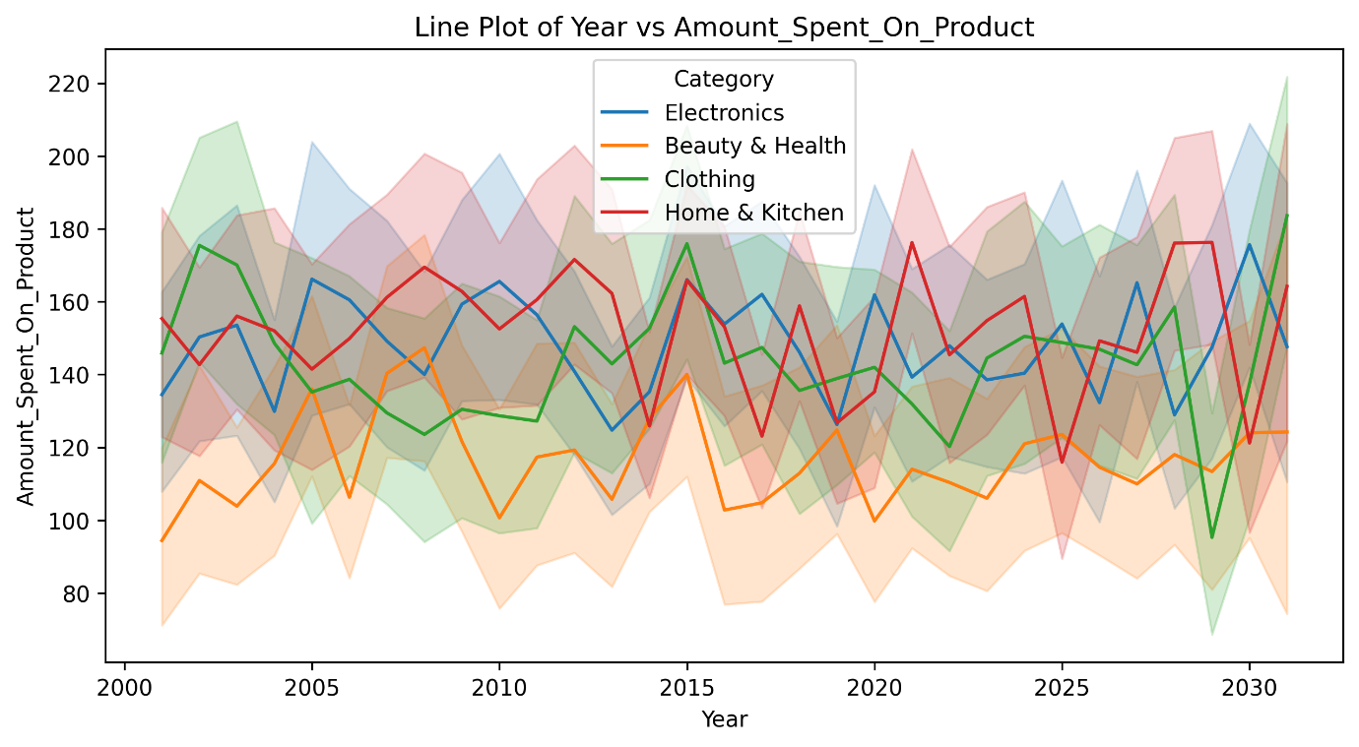

WITH CTE AS

(select productid, YEAR(TransactionDate) as year_Transaction,

SUM(QuantityPurchased * Price) as total_revenue, avg(price) as avg_price

from sales_transaction_new

group by productid, year_Transaction),

product_in as

(select productid, category as productcategory from product_inventory),

product_summary as

(select pi.productcategory, cte.year_Transaction, cte.total_revenue, cte.avg_price from cte

JOIN product_in as pi

ON cte.productid = pi.productid

order by pi.productcategory asc, cte.year_Transaction desc),

year_wise_category as

(select year_Transaction,

SUM(CASE WHEN productcategory='Beauty & Health' THEN total_revenue ELSE 0 END) AS Beauty_Health,

SUM(CASE WHEN productcategory='Clothing' THEN total_revenue ELSE 0 END) AS Clothing,

SUM(CASE WHEN productcategory='Electronics' THEN total_revenue ELSE 0 END) AS Electronics,

SUM(CASE WHEN productcategory='Home & Kitchen' THEN total_revenue ELSE 0 END) AS Home_Kitchen

from product_summary

group by year_Transaction

order by year_Transaction)

select *, CASE

WHEN Beauty_Health >= Clothing AND Beauty_Health >= Electronics AND Beauty_Health >= Home_Kitchen THEN 'Beauty & Health'

WHEN Clothing >= Beauty_Health AND Clothing >= Electronics AND Clothing >= Home_Kitchen THEN 'Clothing'

WHEN Electronics >= Beauty_Health AND Electronics >= Clothing AND Electronics >= Home_Kitchen THEN 'Electronics'

WHEN Home_Kitchen >= Beauty_Health AND Home_Kitchen >= Clothing AND Home_Kitchen >= Electronics THEN 'Home & Kitchen'

END AS max_category_name

from year_wise_category;

This query represent that each year which category having the highest revenue generated

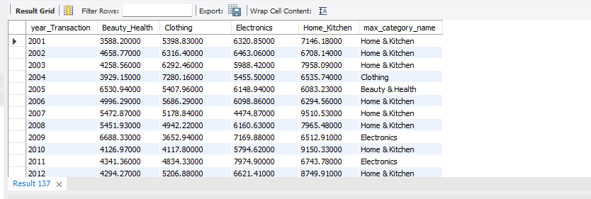

Total number of records present in customer profiles table

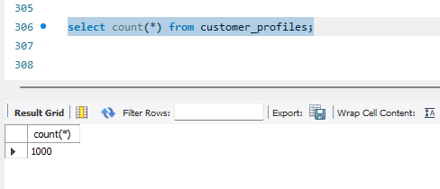

Min joindate and max join date of cuatomer in cutomer profiles table

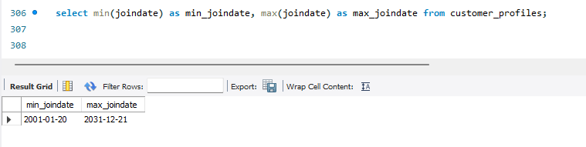

select MONTH(JoinDate) as month_join, count(*) as count_customer from customer_profiles

group by month_join

order by month_join;

Each month how many customers are join in this retail application

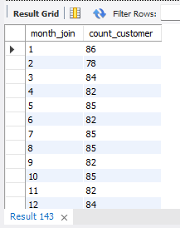

select YEAR(JoinDate) as year_join, count(*) as count_customer from customer_profiles

group by year_join

order by year_join;

Each year how many customers are join

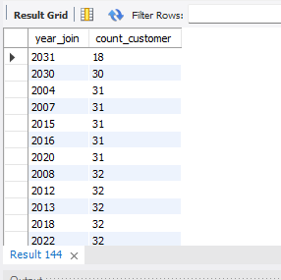

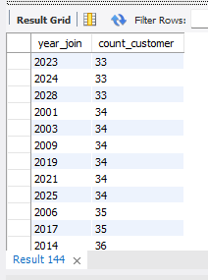

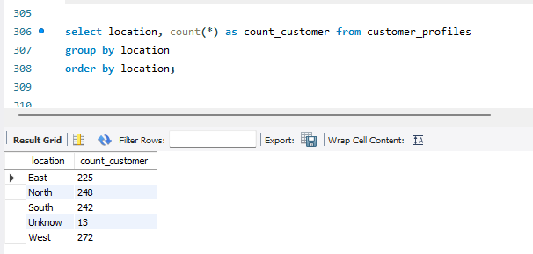

select

COUNT(CASE WHEN Age between 1 and 10 THEN customerid END) AS 1_to_10,

COUNT(CASE WHEN Age between 11 and 20 THEN customerid END) AS 11_to_20,

COUNT(CASE WHEN Age between 21 and 30 THEN customerid END) AS 21_to_30,

COUNT(CASE WHEN Age between 31 and 40 THEN customerid END) AS 31_to_40,

COUNT(CASE WHEN Age between 41 and 50 THEN customerid END) AS 41_to_50,

COUNT(CASE WHEN Age between 51 and 60 THEN customerid END) AS 51_to_60,

COUNT(CASE WHEN Age between 61 and 70 THEN customerid END) AS 61_to_70,

COUNT(CASE WHEN Age between 71 and 80 THEN customerid END) AS 71_to_80,

COUNT(CASE WHEN Age between 81 and 90 THEN customerid END) AS 81_to_90,

COUNT(CASE WHEN Age between 91 and 140 THEN customerid END) AS 91_to_140

from customer_profiles;

Age wise representation of count of customer present in customer profiles table. Maximum 31 to 40 group age people are purchasing more. 21 to 30 age people are growing in there career and after 30 people become stable in finance so, after that purchase of product are increasing.

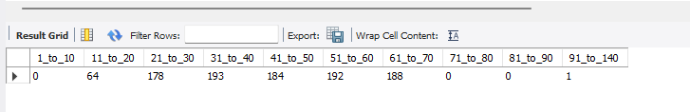

Other group gender are purchasing more than male and female.

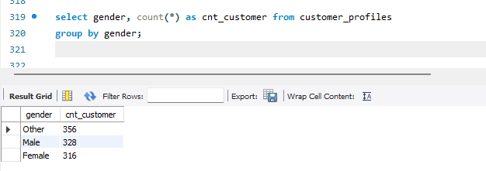

select gender, location, count(*) as cnt_customer from customer_profiles

group by gender, location;

It’s present that gender wise location wise number of customers are present in customer profiles table

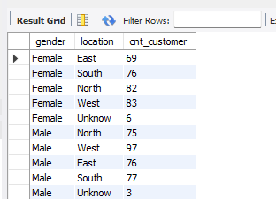

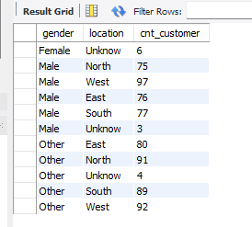

select gender,

COUNT(CASE WHEN Age between 1 and 10 THEN customerid END) AS 1_to_10,

COUNT(CASE WHEN Age between 11 and 20 THEN customerid END) AS 11_to_20,

COUNT(CASE WHEN Age between 21 and 30 THEN customerid END) AS 21_to_30,

COUNT(CASE WHEN Age between 31 and 40 THEN customerid END) AS 31_to_40,

COUNT(CASE WHEN Age between 41 and 50 THEN customerid END) AS 41_to_50,

COUNT(CASE WHEN Age between 51 and 60 THEN customerid END) AS 51_to_60,

COUNT(CASE WHEN Age between 61 and 70 THEN customerid END) AS 61_to_70,

COUNT(CASE WHEN Age between 71 and 80 THEN customerid END) AS 71_to_80,

COUNT(CASE WHEN Age between 81 and 90 THEN customerid END) AS 81_to_90,

COUNT(CASE WHEN Age between 91 and 140 THEN customerid END) AS 91_to_140

from customer_profiles

group by gender;

Gender and age wise number of customer present in each group category

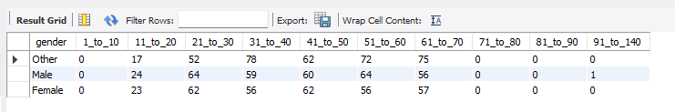

WITH CTE AS

(select cp.Customerid, cp.age, cp.gender, cp.location, st.productid, st.QuantityPurchased, st.transactiondate, st.price, (st.QuantityPurchased * st.price) as amount

from customer_profiles as cp

JOIN (select customerid, productid, QuantityPurchased, transactiondate, price from sales_transaction_new) as st

ON cp.customerid = st.customerid)

select customerid, count(productid) as count_product, sum(amount) as total_amount_spend from cte

group by customerid;

It’s represent the each customer how many product purchase with total amount spend

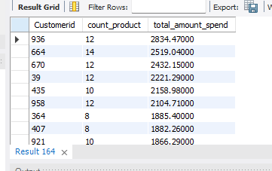

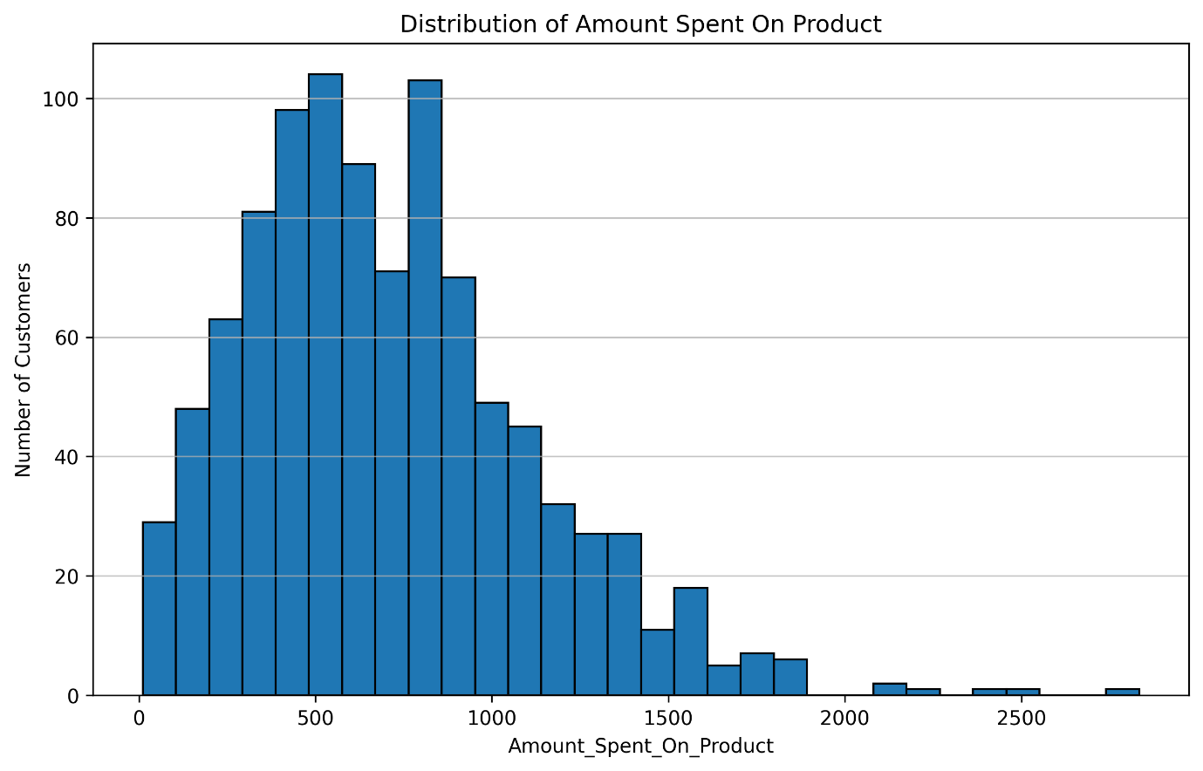

WITH CTE AS

(select cp.Customerid, cp.age, cp.gender, cp.location, st.productid, st.QuantityPurchased, st.transactiondate, st.price, (st.QuantityPurchased * st.price) as amount

from customer_profiles as cp

JOIN (select customerid, productid, QuantityPurchased, transactiondate, price from sales_transaction_new) as st

ON cp.customerid = st.customerid),

customer_bev as

(select customerid, count(productid) as count_product, sum(amount) as total_amount_spend from cte

group by customerid)

select *,

CASE WHEN count_product=0 THEN 'No Order'

WHEN count_product between 1 and 4 THEN 'Low Order'

WHEN count_product between 5 and 10 THEN 'Mid Order'

WHEN count_product > 10 THEN 'High order' END AS Customer_segment

from customer_bev;

According to the purchasing behaviour customer are categories into ‘No order’, ‘Low Order’, ‘Mid order’ and ‘High order’. It’s shows that customer purchasing behaviour.

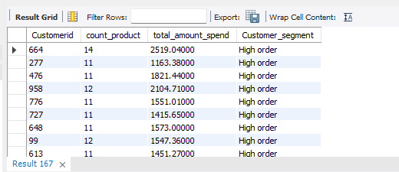

WITH CTE AS

(select cp.Customerid, cp.age, cp.gender, cp.location, st.productid, st.QuantityPurchased, st.transactiondate, st.price, (st.QuantityPurchased * st.price) as amount

from customer_profiles as cp

JOIN (select customerid, productid, QuantityPurchased, transactiondate, price from sales_transaction_new) as st

ON cp.customerid = st.customerid),

customer_bev as

(select customerid, count(productid) as count_product, sum(amount) as total_amount_spend from cte

group by customerid),

customer_seg as

(select *,

CASE WHEN round(total_amount_spend) between 0 and 500 THEN 'very low order'

WHEN round(total_amount_spend) between 501 and 1000 THEN 'low order'

WHEN round(total_amount_spend) between 1001 and 1800 THEN 'Mid order'

WHEN round(total_amount_spend) > 1800 THEN 'High order' END AS Customer_segment

from customer_bev)

select Customer_segment, count(*) as cnt_segement from customer_seg

group by Customer_segment;

This segregation is based on the total amount spent and low order purchase customer are higher. Highest order customer are less.

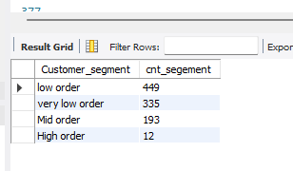

WITH CTE AS

(select cp.Customerid, cp.age, cp.gender, cp.location, st.productid, st.QuantityPurchased, st.transactiondate, st.price,

(st.QuantityPurchased * st.price) as amount, Month(st.transactiondate) as month_transactiondate, YEAR(st.transactiondate) as year_transactiondate

from customer_profiles as cp

JOIN (select customerid, productid, QuantityPurchased, transactiondate, price from sales_transaction_new) as st

ON cp.customerid = st.customerid)

select

COUNT(CASE WHEN month_transactiondate=1 THEN customerid END) AS 'JAN',

COUNT(CASE WHEN month_transactiondate=2 THEN customerid END) AS 'FEB',

COUNT(CASE WHEN month_transactiondate=3 THEN customerid END) AS 'MAR',

COUNT(CASE WHEN month_transactiondate=4 THEN customerid END) AS 'APR',

COUNT(CASE WHEN month_transactiondate=5 THEN customerid END) AS 'MAY',

COUNT(CASE WHEN month_transactiondate=6 THEN customerid END) AS 'JUN',

COUNT(CASE WHEN month_transactiondate=7 THEN customerid END) AS 'JUL',

COUNT(CASE WHEN month_transactiondate=8 THEN customerid END) AS 'AUG',

COUNT(CASE WHEN month_transactiondate=9 THEN customerid END) AS 'SEP',

COUNT(CASE WHEN month_transactiondate=10 THEN customerid END) AS 'OCT',

COUNT(CASE WHEN month_transactiondate=11 THEN customerid END) AS 'NOV',

COUNT(CASE WHEN month_transactiondate=12 THEN customerid END) AS 'DEC'

from cte;

This query represent that total number of customer purchase each month. No sales from AUG till DEC.

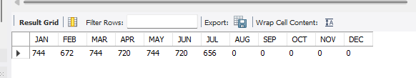

WITH CTE AS

(select cp.Customerid, cp.age, cp.gender, cp.location, st.productid, st.QuantityPurchased, st.transactiondate, st.price,

(st.QuantityPurchased * st.price) as amount, Month(st.transactiondate) as month_transactiondate, YEAR(st.transactiondate) as year_transactiondate

from customer_profiles as cp

JOIN (select customerid, productid, QuantityPurchased, transactiondate, price from sales_transaction_new) as st

ON cp.customerid = st.customerid)

select customerid,

SUM(CASE WHEN month_transactiondate=1 THEN amount ELSE 0 END) AS 'JAN',

SUM(CASE WHEN month_transactiondate=2 THEN amount ELSE 0 END) AS 'FEB',

SUM(CASE WHEN month_transactiondate=3 THEN amount ELSE 0 END) AS 'MAR',

SUM(CASE WHEN month_transactiondate=4 THEN amount ELSE 0 END) AS 'APR',

SUM(CASE WHEN month_transactiondate=5 THEN amount ELSE 0 END) AS 'MAY',

SUM(CASE WHEN month_transactiondate=6 THEN amount ELSE 0 END) AS 'JUN',

SUM(CASE WHEN month_transactiondate=7 THEN amount ELSE 0 END) AS 'JUL',

SUM(CASE WHEN month_transactiondate=8 THEN amount ELSE 0 END) AS 'AUG',

SUM(CASE WHEN month_transactiondate=9 THEN amount ELSE 0 END) AS 'SEP',

SUM(CASE WHEN month_transactiondate=10 THEN amount ELSE 0 END) AS 'OCT',

SUM(CASE WHEN month_transactiondate=11 THEN amount ELSE 0 END) AS 'NOV',

SUM(CASE WHEN month_transactiondate=12 THEN amount ELSE 0 END) AS 'DEC',

SUM(amount) as total_amount_spend

from cte

group by customerid;

Customer wise each month amount spent to any of the product. Customerid – 464 is the lowest amount spend or the customer and customer- 936 is the highest customer how purchase the amount with spenting more money

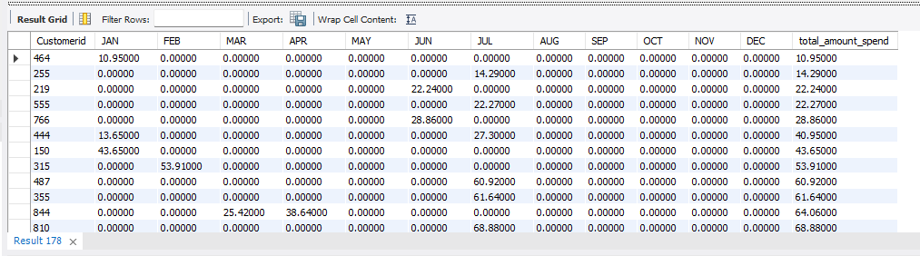

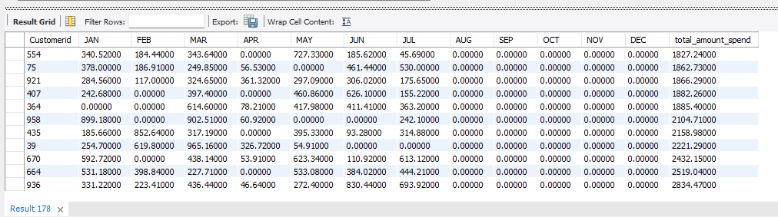

WITH CTE AS

(select cp.Customerid, cp.age, cp.gender, cp.location, st.productid, st.QuantityPurchased, st.transactiondate, st.price,

(st.QuantityPurchased * st.price) as amount, Month(st.transactiondate) as month_transactiondate, YEAR(st.transactiondate) as year_transactiondate

from customer_profiles as cp

JOIN (select customerid, productid, QuantityPurchased, transactiondate, price from sales_transaction_new) as st

ON cp.customerid = st.customerid)

select IFNULL(customerid, 'TOTAL') AS customerid,

SUM(CASE WHEN year_transactiondate=2031 THEN amount ELSE 0 END) AS '2031',

SUM(CASE WHEN year_transactiondate=2030 THEN amount ELSE 0 END) AS '2030',

SUM(CASE WHEN year_transactiondate=2029 THEN amount ELSE 0 END) AS '2029',

SUM(CASE WHEN year_transactiondate=2028 THEN amount ELSE 0 END) AS '2028',

SUM(CASE WHEN year_transactiondate=2027 THEN amount ELSE 0 END) AS '2027',

SUM(CASE WHEN year_transactiondate=2026 THEN amount ELSE 0 END) AS '2026',

SUM(CASE WHEN year_transactiondate=2025 THEN amount ELSE 0 END) AS '2025',

SUM(CASE WHEN year_transactiondate=2024 THEN amount ELSE 0 END) AS '2024',

SUM(CASE WHEN year_transactiondate=2023 THEN amount ELSE 0 END) AS '2023',

SUM(CASE WHEN year_transactiondate=2022 THEN amount ELSE 0 END) AS '2022',

SUM(CASE WHEN year_transactiondate=2021 THEN amount ELSE 0 END) AS '2021',

SUM(CASE WHEN year_transactiondate=2020 THEN amount ELSE 0 END) AS '2020',

SUM(CASE WHEN year_transactiondate=2019 THEN amount ELSE 0 END) AS '2019',

SUM(CASE WHEN year_transactiondate=2018 THEN amount ELSE 0 END) AS '2018',

SUM(CASE WHEN year_transactiondate=2017 THEN amount ELSE 0 END) AS '2017',

SUM(CASE WHEN year_transactiondate=2016 THEN amount ELSE 0 END) AS '2016',

SUM(CASE WHEN year_transactiondate=2015 THEN amount ELSE 0 END) AS '2015',

SUM(CASE WHEN year_transactiondate=2014 THEN amount ELSE 0 END) AS '2014',

SUM(CASE WHEN year_transactiondate=2013 THEN amount ELSE 0 END) AS '2013',

SUM(CASE WHEN year_transactiondate=2012 THEN amount ELSE 0 END) AS '2012',

SUM(CASE WHEN year_transactiondate=2011 THEN amount ELSE 0 END) AS '2011',

SUM(CASE WHEN year_transactiondate=2010 THEN amount ELSE 0 END) AS '2010',

SUM(CASE WHEN year_transactiondate=2009 THEN amount ELSE 0 END) AS '2009',

SUM(CASE WHEN year_transactiondate=2008 THEN amount ELSE 0 END) AS '2008',

SUM(CASE WHEN year_transactiondate=2007 THEN amount ELSE 0 END) AS '2007',

SUM(CASE WHEN year_transactiondate=2006 THEN amount ELSE 0 END) AS '2006',

SUM(CASE WHEN year_transactiondate=2005 THEN amount ELSE 0 END) AS '2005',

SUM(CASE WHEN year_transactiondate=2004 THEN amount ELSE 0 END) AS '2004',

SUM(CASE WHEN year_transactiondate=2003 THEN amount ELSE 0 END) AS '2003',

SUM(CASE WHEN year_transactiondate=2002 THEN amount ELSE 0 END) AS '2002',

SUM(CASE WHEN year_transactiondate=2001 THEN amount ELSE 0 END) AS '2001',

SUM(amount) as total_amount_spend,

count(amount) as frequency_buying_yearly

from cte

group by customerid WITH ROLLUP;

Year wise customer purchase behaviour

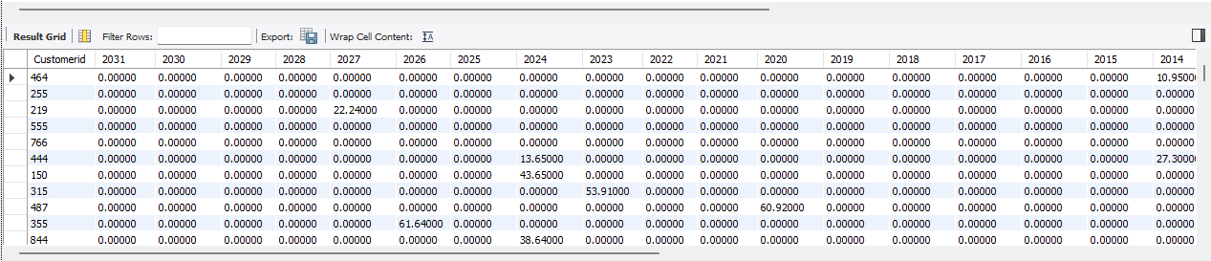

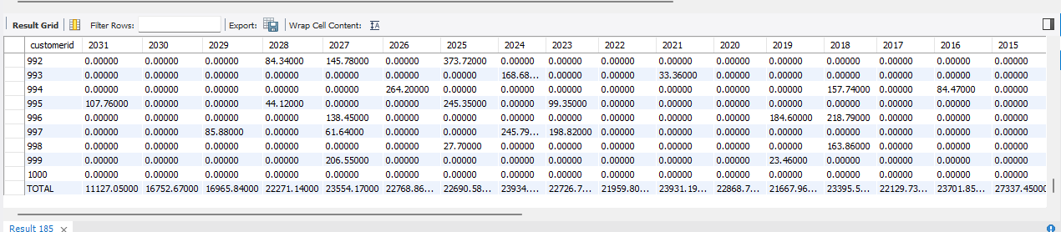

WITH CTE AS

(select cp.Customerid, cp.age, cp.gender, cp.location, st.productid, st.QuantityPurchased, st.transactiondate, st.price,

(st.QuantityPurchased * st.price) as amount, Month(st.transactiondate) as month_transactiondate, YEAR(st.transactiondate) as year_transactiondate

from customer_profiles as cp

JOIN (select customerid, productid, QuantityPurchased, transactiondate, price from sales_transaction_new) as st

ON cp.customerid = st.customerid)

select year_transactiondate,

SUM(CASE WHEN age between 11 and 20 THEN amount ELSE 0 END) AS 11_20,

SUM(CASE WHEN age between 21 and 30 THEN amount ELSE 0 END) AS 21_30,

SUM(CASE WHEN age between 31 and 40 THEN amount ELSE 0 END) AS 31_40,

SUM(CASE WHEN age between 41 and 50 THEN amount ELSE 0 END) AS 41_50,

SUM(CASE WHEN age between 51 and 60 THEN amount ELSE 0 END) AS 51_60,

SUM(CASE WHEN age between 61 and 70 THEN amount ELSE 0 END) AS 61_70,

SUM(CASE WHEN age between 71 and 140 THEN amount ELSE 0 END) AS 71_140,

sum(amount) as total_amount_spend

from cte

group by year_transactiondate;

Age group wise amount spent each year

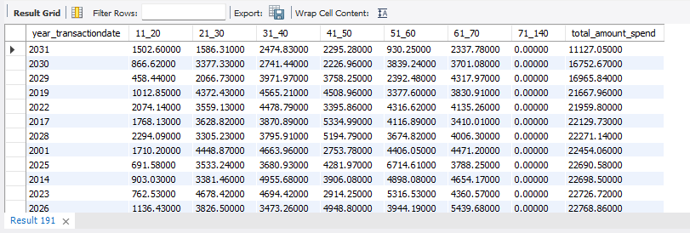

WITH CTE AS

(select cp.Customerid, cp.age, cp.gender, cp.location, st.productid, st.QuantityPurchased, st.transactiondate, st.price,

(st.QuantityPurchased * st.price) as amount, Month(st.transactiondate) as month_transactiondate, YEAR(st.transactiondate) as year_transactiondate

from customer_profiles as cp

JOIN (select customerid, productid, QuantityPurchased, transactiondate, price from sales_transaction_new) as st

ON cp.customerid = st.customerid),

cust_prod as

(select customerid, productid, count(*) as cnt from cte

group by customerid, productid

having count(*)>1

order by customerid, productid),

cust as

(select customerid, productid, month_transactiondate, year_transactiondate

from cte where (customerid, productid) in(select customerid,productid from cust_prod)

order by customerid, productid asc, year_transactiondate desc)

select *,

IFNULL(ABS(year_transactiondate - LAG(year_transactiondate) OVER (PARTITION BY customerid, productid ORDER BY year_transactiondate)), 0) AS year_diff

from cust;

This query represent that which product are purchase more with buying behaviour or year difference between same product purchase. Customer are buying same product in same year or having 1,2,3,4…etc gap for buying same product.

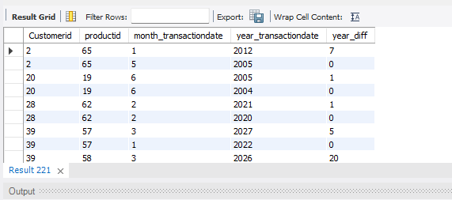

WITH CTE AS

(select cp.Customerid, cp.age, cp.gender, cp.location, st.productid, st.QuantityPurchased, st.transactiondate, st.price,

(st.QuantityPurchased * st.price) as amount, Month(st.transactiondate) as month_transactiondate, YEAR(st.transactiondate) as year_transactiondate

from customer_profiles as cp

JOIN (select customerid, productid, QuantityPurchased, transactiondate, price from sales_transaction_new) as st

ON cp.customerid = st.customerid),

cust_prod as

(select customerid, productid, count(*) as cnt from cte

group by customerid, productid

having count(*)>1

order by customerid, productid),

cust as

(select customerid, productid, month_transactiondate, year_transactiondate

from cte where (customerid, productid) in(select customerid,productid from cust_prod)

order by customerid, productid asc, year_transactiondate desc),

cust_purchase as

(select *,

IFNULL(ABS(year_transactiondate - LAG(year_transactiondate) OVER (PARTITION BY customerid, productid ORDER BY year_transactiondate)), 0) AS year_diff

from cust)

select year_diff , count(distinct customerid) as cnt from cust_purchase

group by year_diff

order by year_diff;

Zero presenet that same year customer purchased more same product after that pattern are increasing or decreasing order

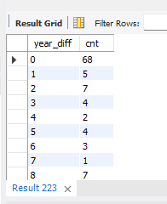

SELECT

customerid,

YEAR(transactiondate) AS purchase_year,

MONTH(transactiondate) AS purchase_month,

COUNT(*) AS transactions_in_month

FROM sales_transaction_new

GROUP BY customerid, purchase_year, purchase_month

ORDER BY customerid, purchase_year, purchase_month;

Purchases per customer happen each year/month

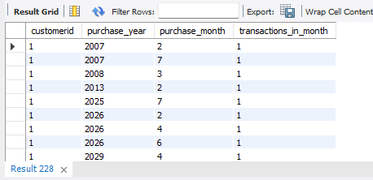

WITH CTE AS (

SELECT

cp.Customerid,

st.transactiondate

FROM customer_profiles cp

JOIN sales_transaction_new st ON cp.customerid = st.customerid

),

frequency_calc AS (

SELECT

customerid,

transactiondate,

LAG(transactiondate) OVER (PARTITION BY customerid ORDER BY transactiondate) AS prev_transaction

FROM CTE

)

SELECT

customerid,

COUNT(*) AS total_transactions,

ROUND(AVG(DATEDIFF(transactiondate, prev_transaction)), 2) AS avg_days_between_purchases

FROM frequency_calc

WHERE prev_transaction IS NOT NULL

GROUP BY customerid

ORDER BY customerid;

Customer did how many transaction with avearge days purchasing pattern

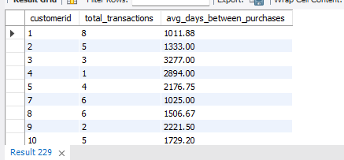

SELECT customerid, MAX(transactiondate) AS last_purchase, DATEDIFF(CURDATE(), MAX(transactiondate)) AS recency,

COUNT(*) AS frequency, SUM(QuantityPurchased * price) AS monetary

FROM sales_transaction_new

GROUP BY customerid;

This query represent the last purchase date of customer with difference between the number of days happend from today’s date that is recency and number of time customer purchased the product that is frequency of customer with total amount spent is monetary

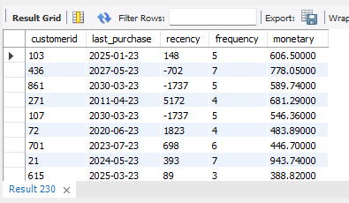

SELECT customerid, MIN(transactiondate) AS first_purchase, MAX(transactiondate) AS last_purchase,

DATEDIFF(MAX(transactiondate), MIN(transactiondate)) AS customer_tenure_days

FROM sales_transaction_new

GROUP BY customerid;

Customer first and last day of purchase with total days spent on this retail application

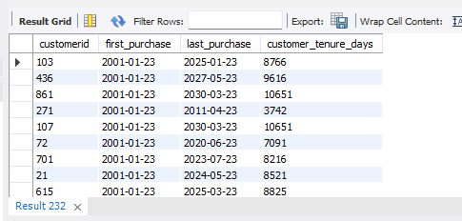

WITH rfm_raw AS (

SELECT

customerid,

MAX(transactiondate) AS last_purchase,

DATEDIFF(CURDATE(), MAX(transactiondate)) AS recency,

COUNT(*) AS frequency,

round(SUM(QuantityPurchased * price)) AS monetary

FROM sales_transaction_new

GROUP BY customerid

),

rfm_scored AS (

SELECT *,CASE WHEN recency <= 30 THEN 3

WHEN recency <= 90 THEN 2

ELSE 1 END AS r_score,

CASE WHEN frequency >= 10 THEN 3

WHEN frequency >= 5 THEN 2

ELSE 1 END AS f_score,

CASE WHEN monetary >= 10000 THEN 3

WHEN monetary >= 5000 THEN 2

ELSE 1 END AS m_score

FROM rfm_raw

),

rfm_final AS (

SELECT *,

CONCAT(r_score, f_score, m_score) AS rfm_score,

CASE

WHEN r_score = 3 AND f_score = 3 AND m_score = 3 THEN 'Champion'

WHEN r_score = 3 AND f_score = 2 THEN 'Loyal'

WHEN r_score = 2 AND f_score >= 2 THEN 'Potential Loyalist'

WHEN r_score = 1 AND f_score = 3 THEN 'At Risk'

WHEN r_score = 1 AND f_score = 1 AND m_score = 1 THEN 'Lost'

ELSE 'Others'

END AS rfm_category

FROM rfm_scored

)

SELECT

customerid, recency, frequency, monetary, r_score, f_score, m_score, rfm_score, rfm_category

FROM rfm_final ORDER BY rfm_score DESC;

This query represent that customer behaviour on the basis of recency, frequency and monentay. Calculating the score of each behaviour and on the basis of rfm category are decided like, champions, loyal, potential loyalist, at risk, lost and others.

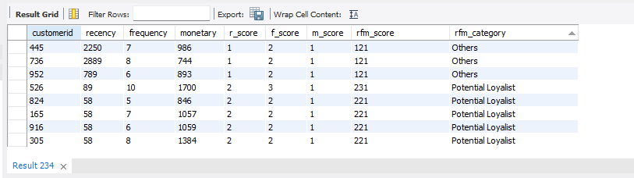

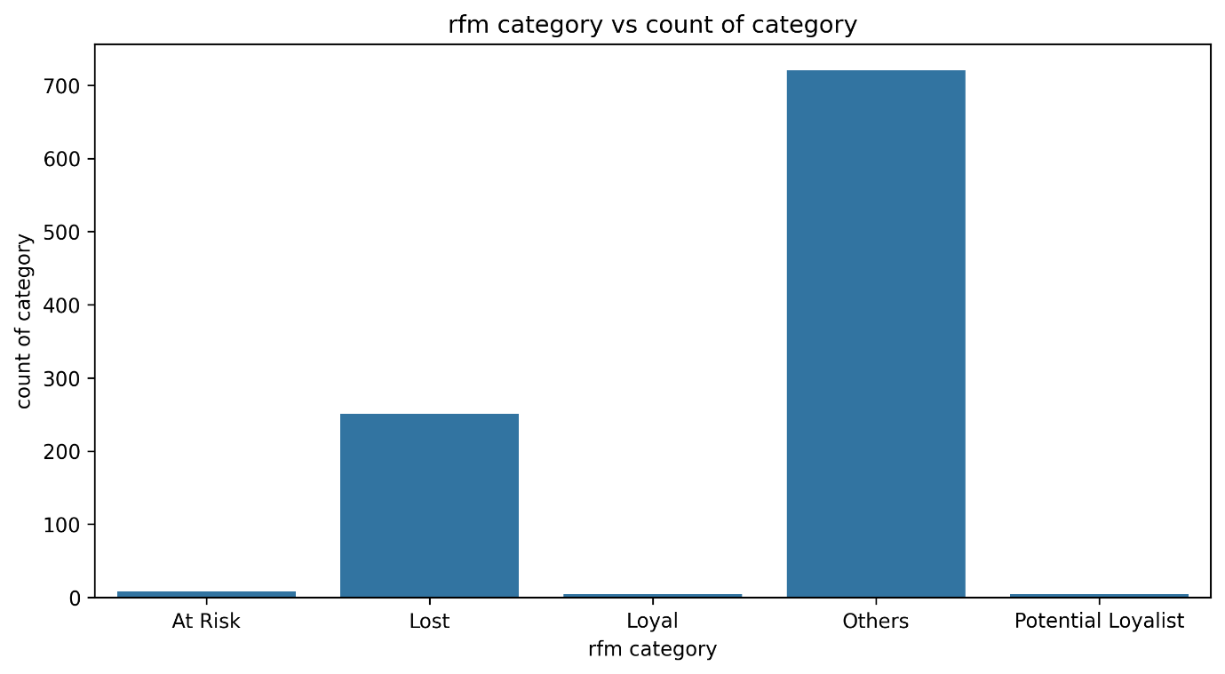

# **Recommandation to the problem:**

1. People have low awareness about beauty and health, so they are buying fewer products. The data covers the years 2001 to 2031, and only in 2005 did the revenue from health and beauty products reach its highest point.
2. There are no "champion" customers in this data. The focus should be on retaining **loyal customers** and turning **potential loyalists** into champions by offering new deals or discounts.
3. **Loyal Customers**: Offer coupons or bigger discounts if they buy products worth a certain amount.
4. **Potential Loyalists**: Give them bonus loyality point for 2 or 3 puchase to they have buy more product with this point or redeem them.
5. **At-Risk Customers**: Offer exchange deals (e.g., trade in old products and pay a small amount for new ones) or run big sales like Amazon’s Big Billion Days to bring them back.

To view the same analysis in pandas refer the link :-

https://colab.research.google.com/drive/1UgCrF6BhB1VPbKQyjjYISk-VuAMPSuA0#scrollTo=pNksgM_0Gy0L